**Get Informed**

**1. From the Home page, navigate to the Help page.**

**2. Read help information!**

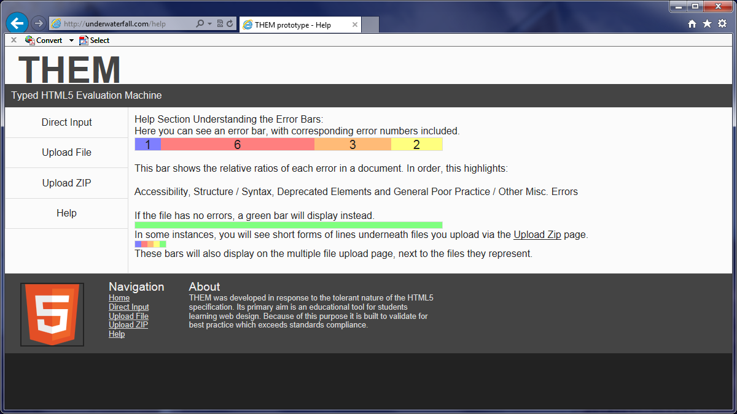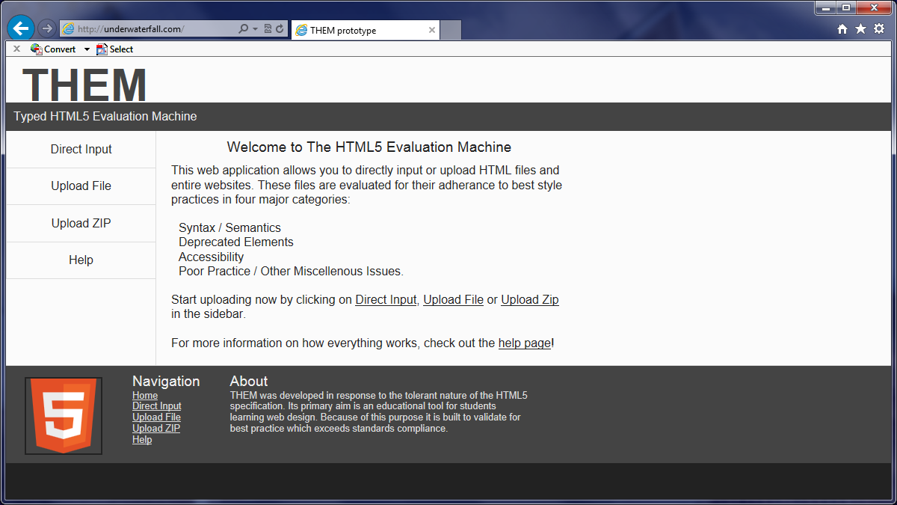

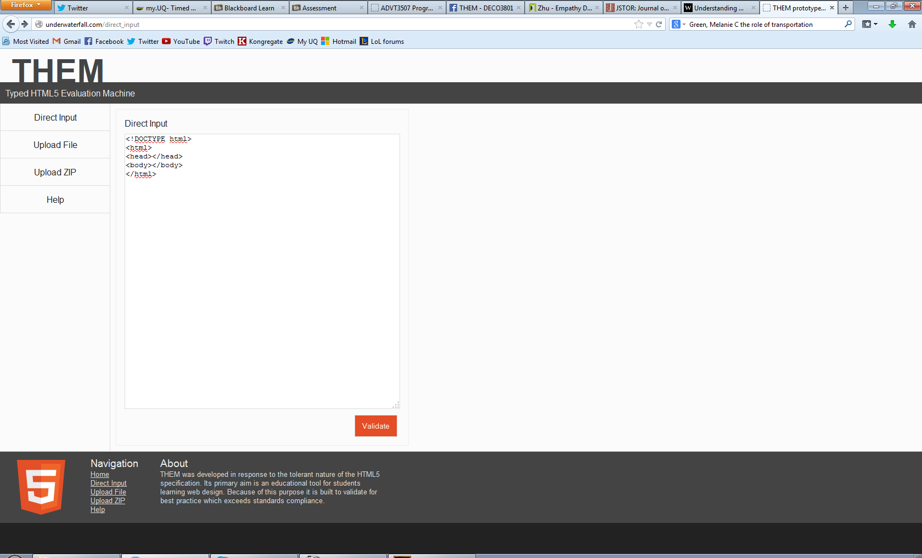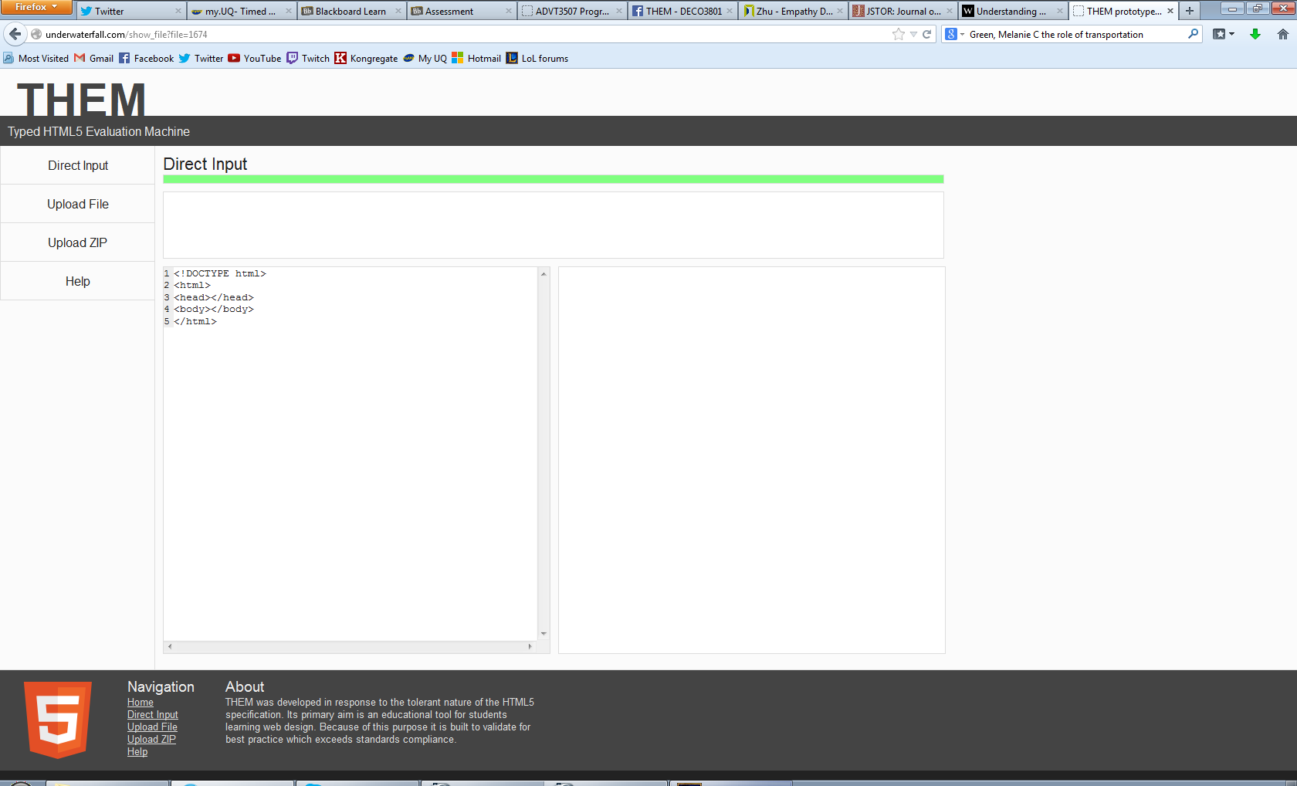**Direct Input**

**1. Navigate to Direct Input page.**

**3. Click 'Validate'.**

**2. Enter some HTML.**

**All good!**

**3. Click 'Validate'.**

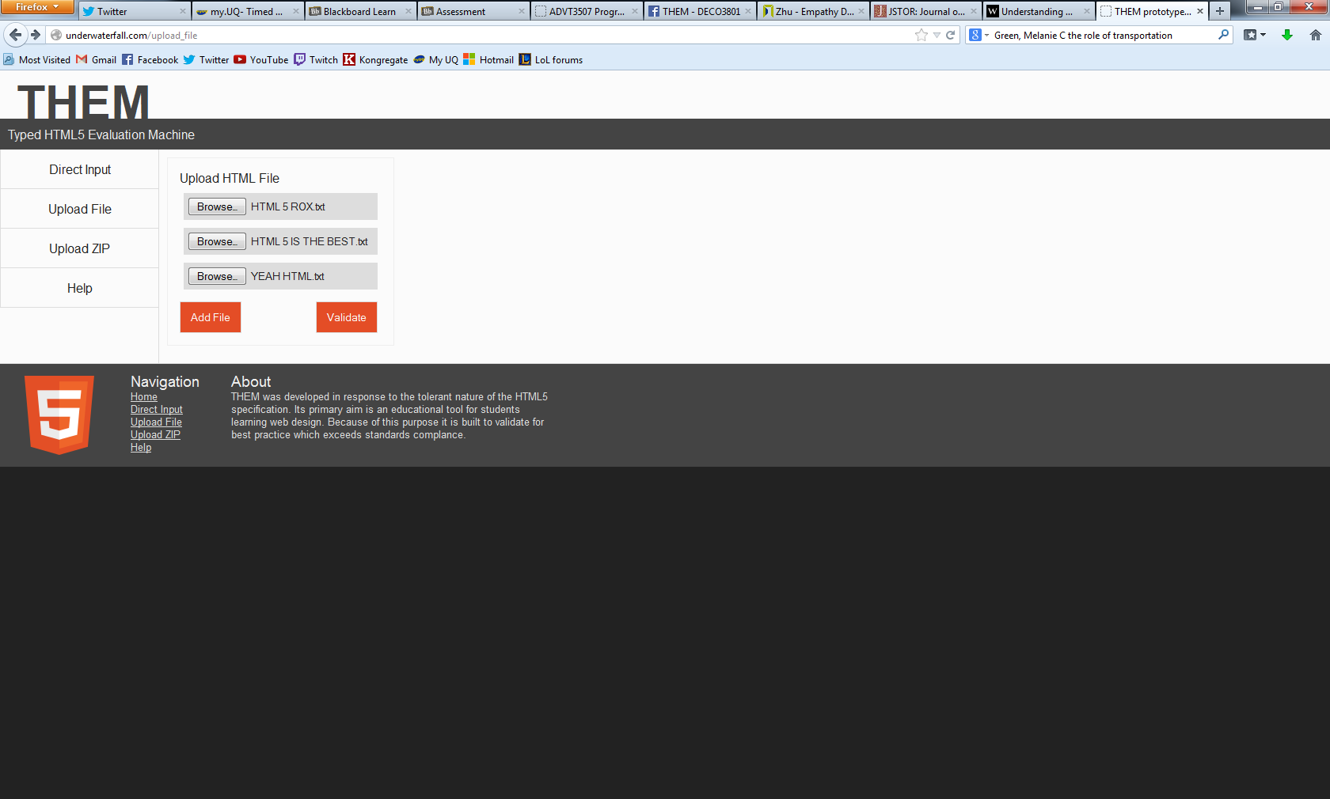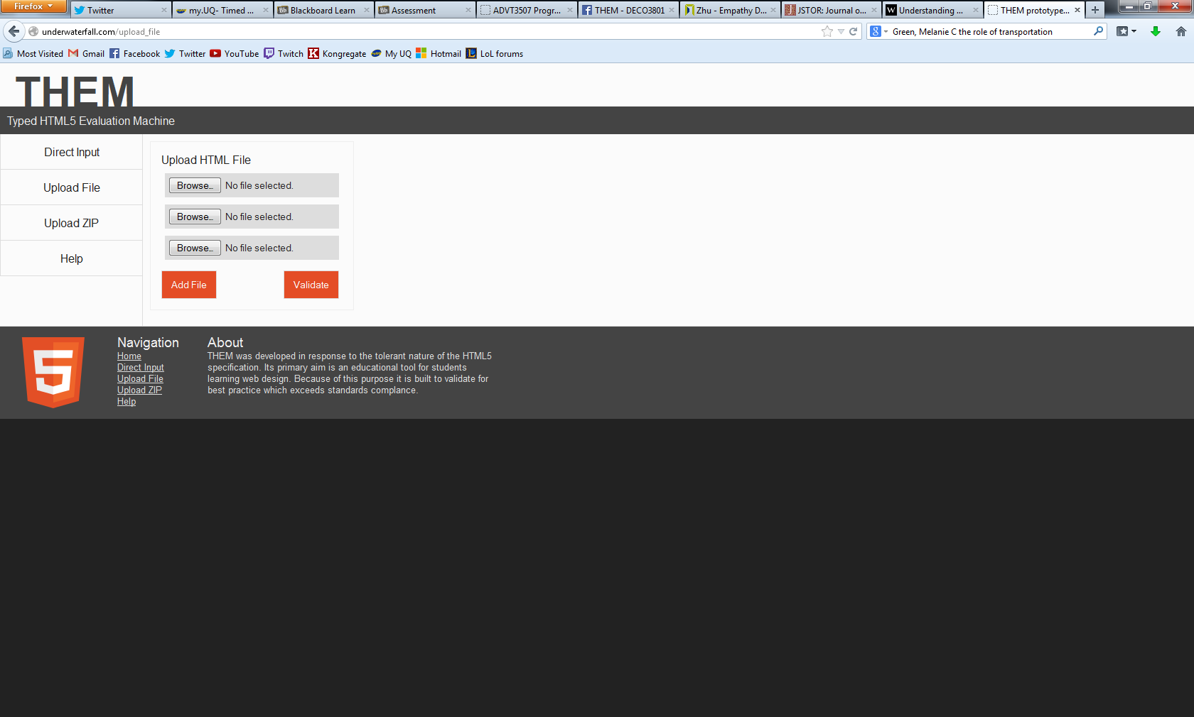**Upload File**

**2. Browse to upload file(s).**

**1. Navigate to Upload File page.**

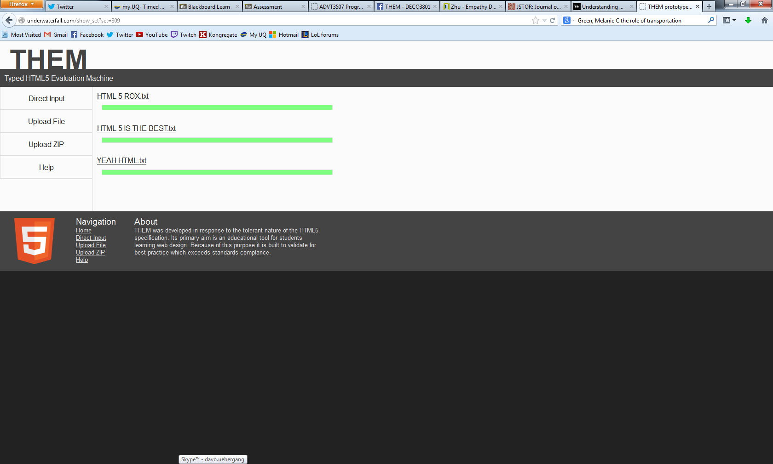

**All good!**

**Scenario:**

Fixing a file based on the error messages provided and revalidates it.

1) Error

2) User starts fixing the error by using their preferred text editor.

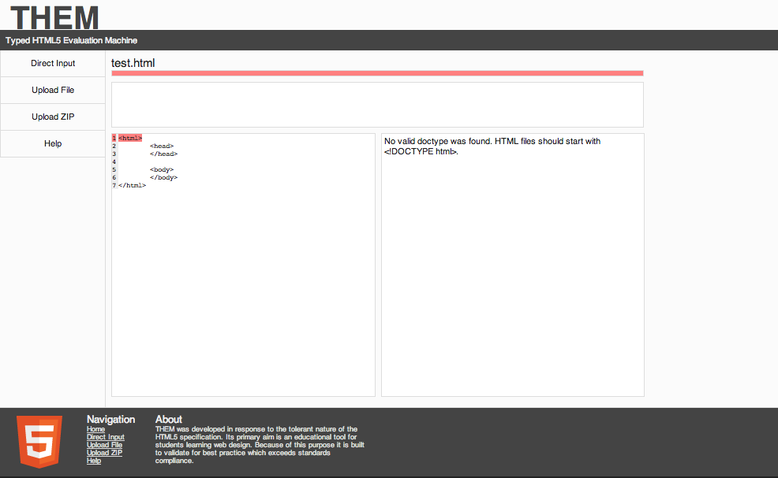

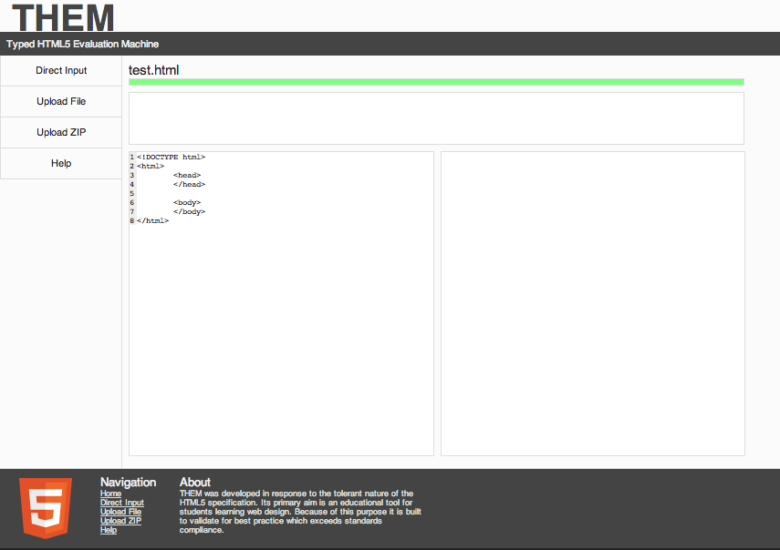3) The HTML has been fixed and resubmitted.

**Scenario:**

Uploading a zipped website and validate it for errors.

1. Navigate to the upload zip tab.

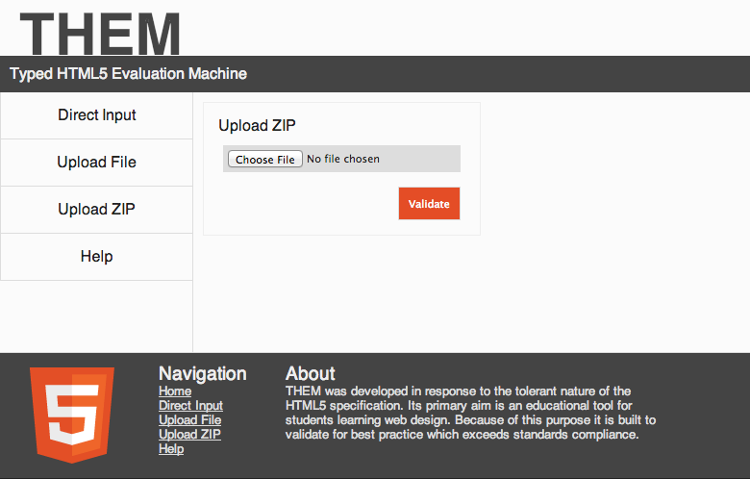

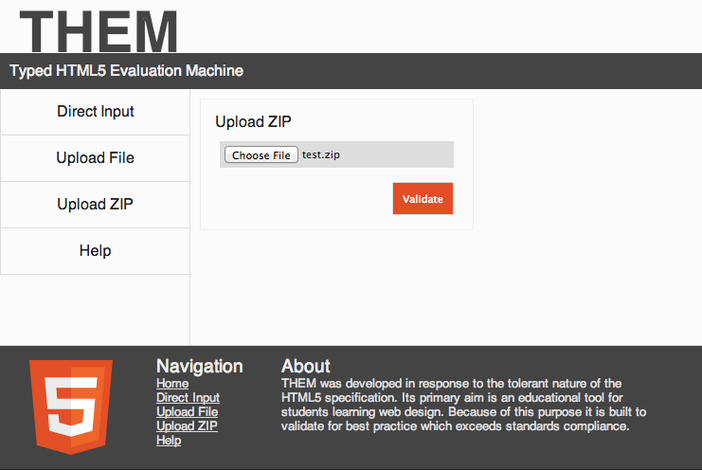2) Zipped website is added.

1. The zip file has been validated. In this case, the zip contained a single file.

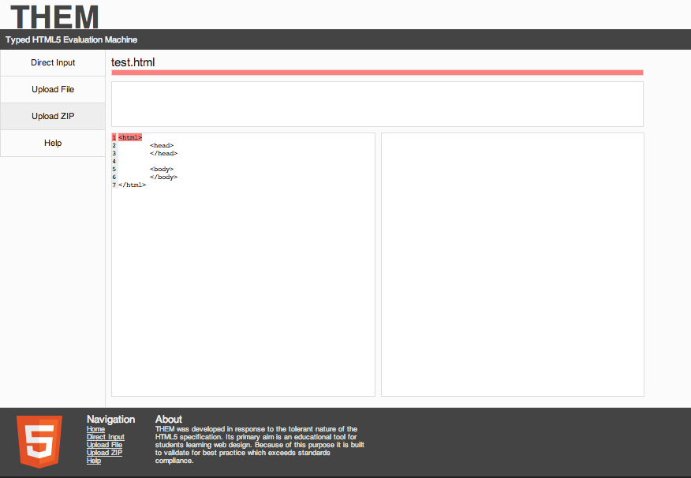

**Scenario:**

Upload any non-HTML file type.

1) Added a non-HTML file, in this case, it is a PDF file.

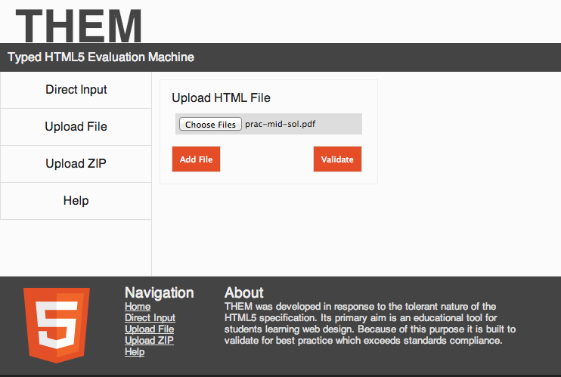

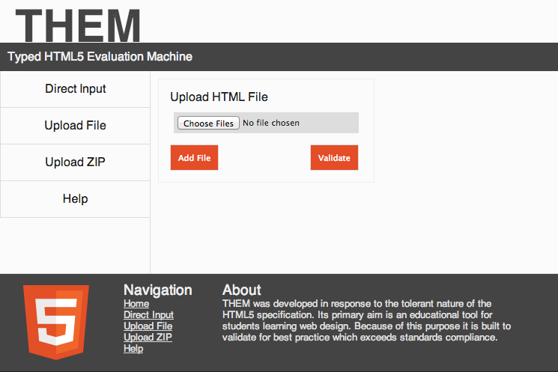2) The single non-HTML file is rejected, and the user informed of the error.

The file you have uploaded is not a HTML file.

Try again